Features are listed below.Elevated,Average and Down cast are used to indicate the importance of featurs

|  |  |  |  |
| --- | --- | --- | --- |
| Feature id | Description | Priority | Requester |
| FE -A | Internet based and can use from devices such as desktop,laptop,mobile and tablet | Elevated |  |
| FE-B | Can use the real buyer and user. | Elevated |  |
| FE-C | Buyer and seler history such as  The buyer can see the seller history how much land he sold and it is verified or not. | Elevated |  |
| FE-D | The seller report will justify for the user | Average |  |

Use Cases

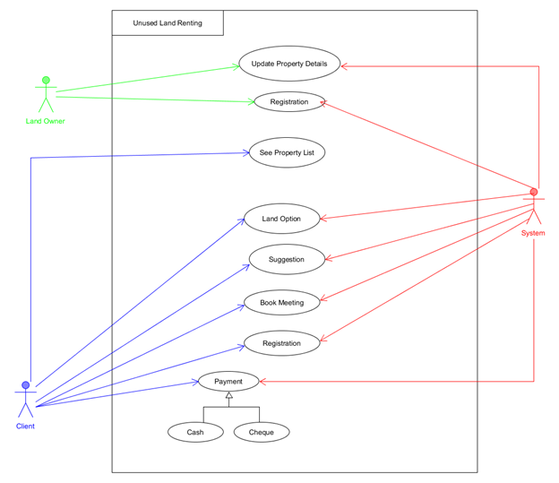

|  |  |
| --- | --- |
| **FE-A – Land owner Verifciation** | |
| **FE02_UC01** - User verification | |
| **Brief Description** | The land owner opens up the portal and the portal shows the login form for access..He can update the price list |
| **Pre-condition/s** | * User is not logged in already |
| **Priority** | Elevated |
| **Actor/s** | Land owner |
| **Main Success Scenario** | 1. Land owner opens up the web portal 2. Land owner updzte the price list. 3. System will update this. 4. The client can see all the details about the land. |
| **Notes** | * The land owner musr feel the required form of the system. |

|  |  |
| --- | --- |
| FE-B-System and Management | |
| Brief Description | System will update the land opyion and client can see. |
| Pre-Conditio | Land must be legal. |
| Priorirty | Elevated. |
| Actors | Client |
| Main Success | 1.System will book meeting with the client and land owner.  2.Client can book the land.  3.They can discuss with each other and our system will monitoring this. |
| Notes | System will provide the options for client. |

|  |  |
| --- | --- |
| FE-C-Payment Method | |
| Brief Description | Here the payment system will be discussed. |
| Pre -Conditon | System will follow up the client. |
| Priority | Elevated |
| Actors | Client |
| Main Success | 1.Client will pay the money to the owner.  2.Here the client can pay the money by cheque or cash.  3.System will follow all the management by the client. |
| Notes | Here the deal will end. |